Moringa Steam - English Translation
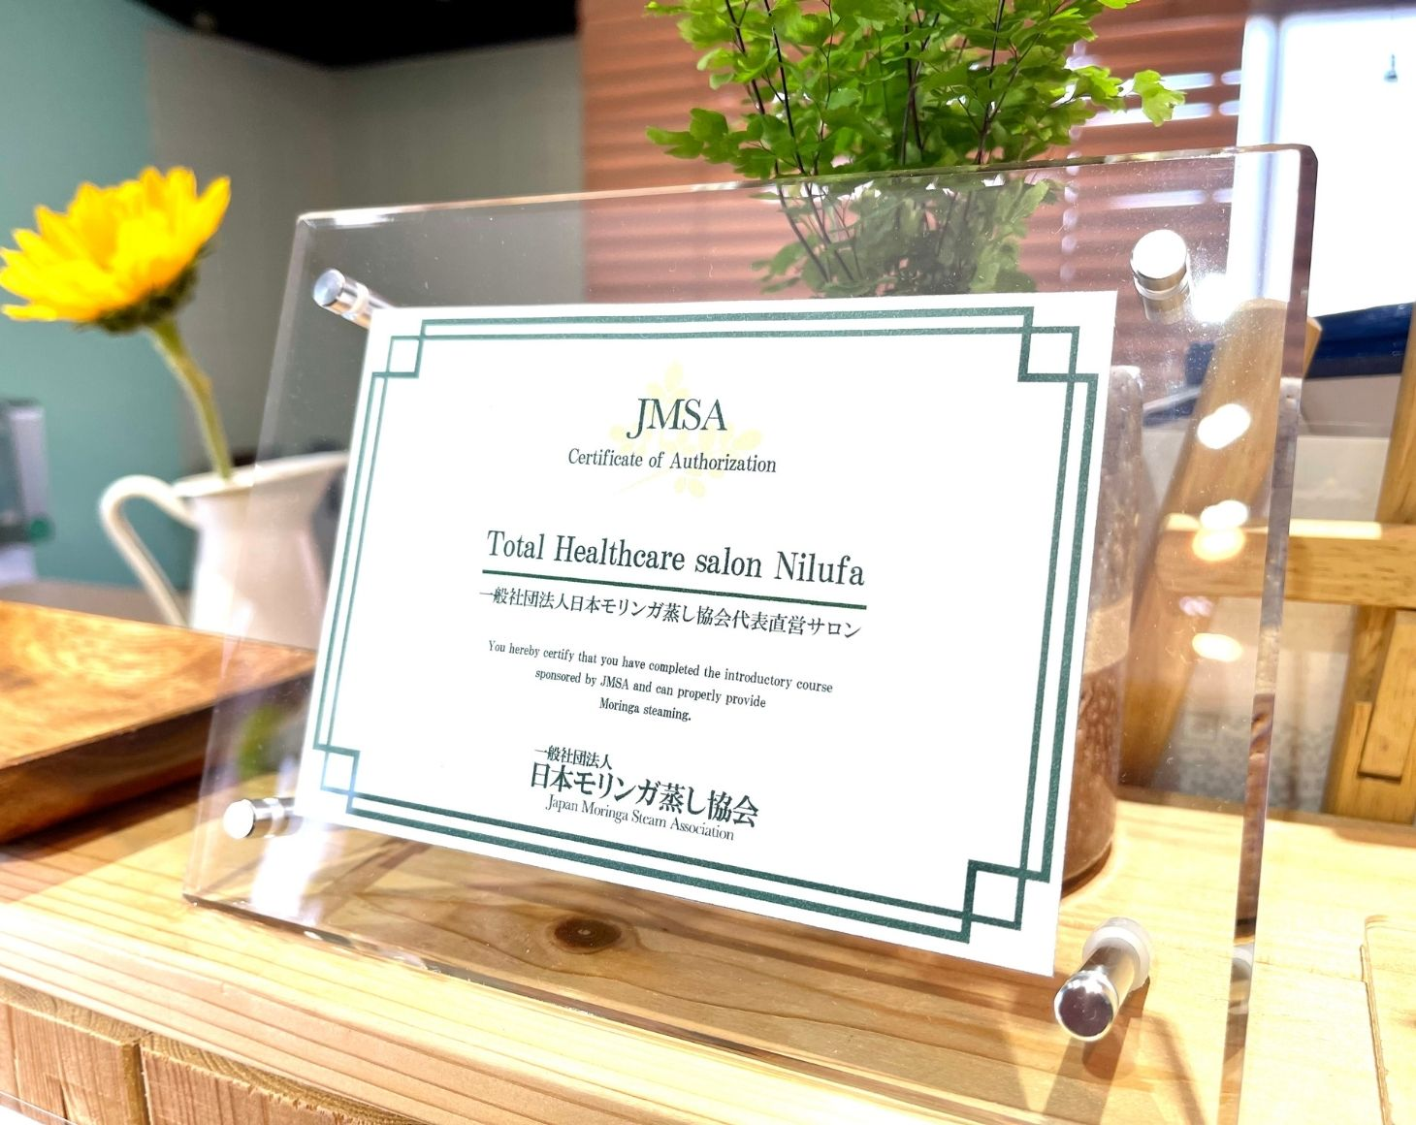
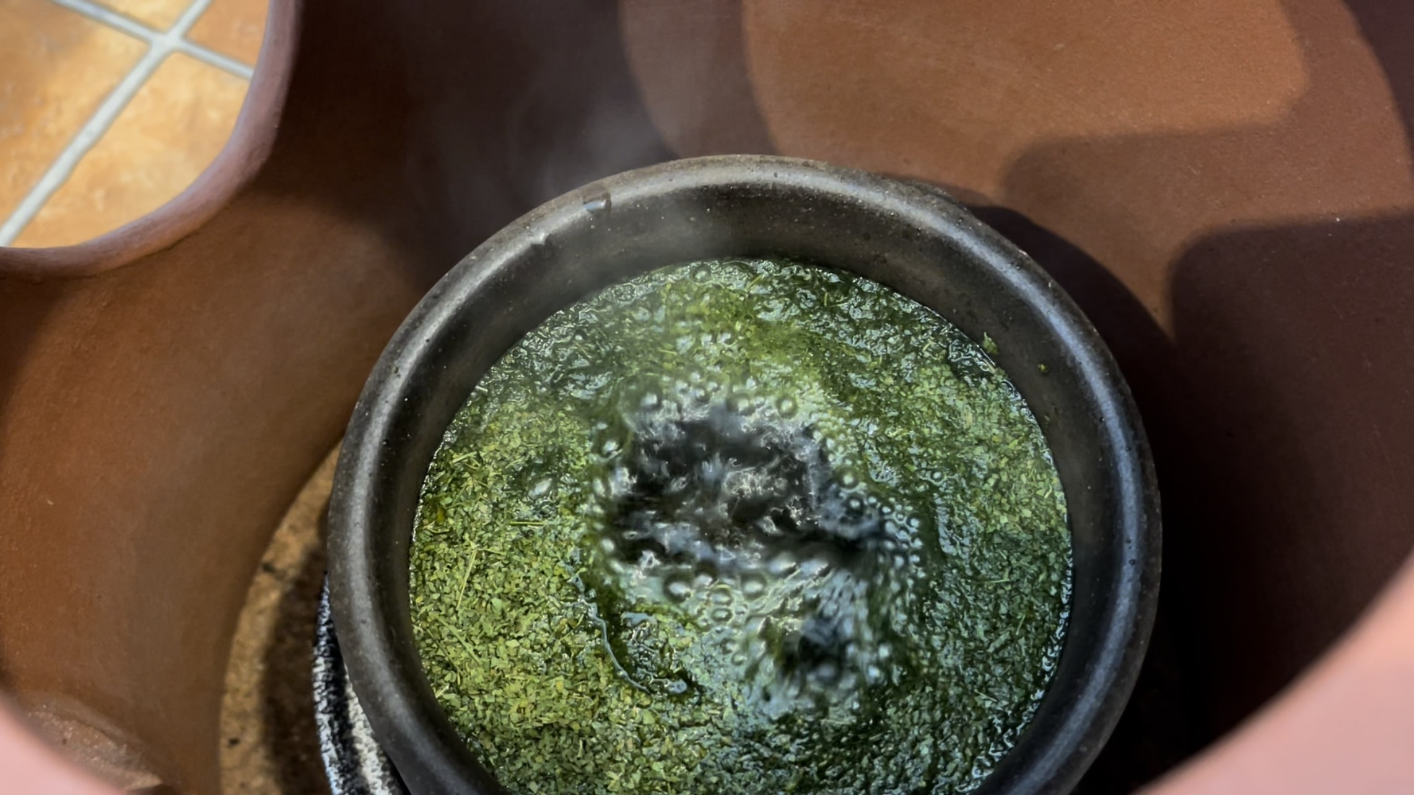
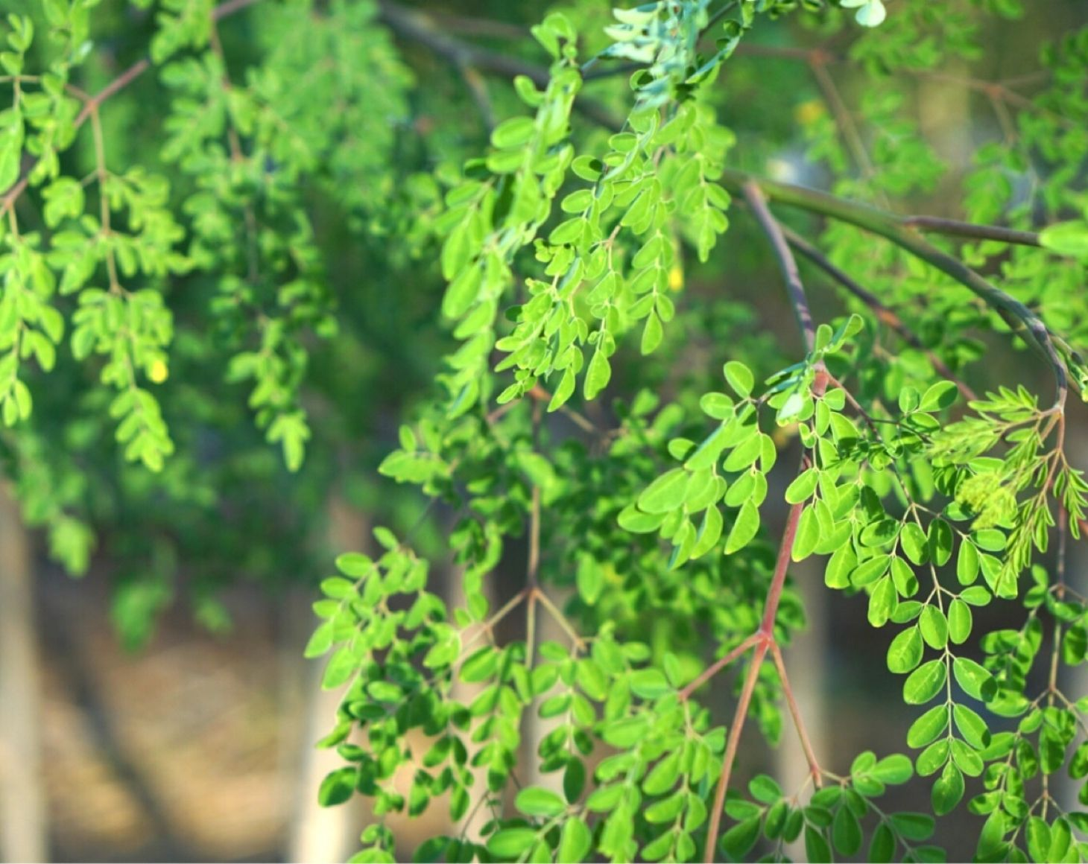

Sweat with Moringa

Bringing "The Miracle Tree" Moringa × Hot Bath Therapy Nationwide

Experience Moringa Steaming at Your Salon
News List
- 2019.09.03 Opening Moringa Steam Therapist® Training & Business School

"The Miracle Tree" - Moringa
Moringa (Moringa Oleifera) is a plant native to subtropical regions that contains over 90 essential nutrients in a well-balanced manner. It is also called the "Miracle Tree," "Tree of Life," and "Medicine Box Tree," and is the ultimate superfood left to humanity to supplement modern nutritional deficiencies.
The ancient Indian medical text "Ayurveda" states that it is effective in preventing over 300 types of diseases. Useful components are contained in all parts of the plant: leaves, flowers, pods, seeds, bark, and stems.


Spreading the Power of "The Miracle Tree" Moringa × Hot Bath Therapy Nationwide
I am Mizuguchi, the Representative Director of the Japan Moringa Steaming Association.
Although the superfood "Moringa" has gradually become known in Japan in recent years, I became captivated by its charm even before it became famous and went to study in America and the Philippines.
I want to spread nationwide the message that it is necessary in modern society to absorb Moringa's nutrition not only internally but also externally.
Furthermore, I chose the association format because I wanted to energize the entire industry through Moringa steaming by connecting with salon owners who previously had almost no horizontal connections.
If you would like to experience Moringa steaming, please contact our certified salons nationwide.
We are still recruiting salons for introduction.
Let's expand the circle of Moringa together!

What is Moringa Steaming?
Moringa steaming is a hot bath therapy using steam from steamed leaves of the "Miracle Tree" Moringa. In contrast to its aromatic green tea-like scent that creates a relaxed and calm atmosphere, you can experience amazing effects in less than 5 minutes: sweat pouring from your pores, incredible detoxification, skincare benefits, diet support, relief from gynecological concerns, fertility support, and increased basal body temperature.
Moringa steaming is recommended for everyone who wants to improve their constitution, but our association's original Moringa steaming menu "JMSA Moringa Steam®" is especially recommended for the following people:

1. For Those Trying to Conceive
While mugwort steaming is famous for fertility support, it can actually only be offered for half the month to those trying to conceive. Moringa steaming can be safely offered anytime - even during pregnancy. Some clients have come for warming treatments until the day before delivery! ♪


2. For Those with Hay Fever or Atopy
The most common feedback from customers who have continued Moringa steaming for several years is: "I feel like my hay fever symptoms have eased compared to last year!" You can detox thoroughly and achieve smooth, beautiful skin. It's also popular among those with atopy.


3. Diet Support
Although you're just sitting during Moringa steaming, you can actually burn calories equivalent to 3 hours of aerobics. If you're troubled by swelling, please try it right away. The amino acid power contained in Moringa may also help?!


Testimonials from Those Who Experienced JMSA Moringa Steam®
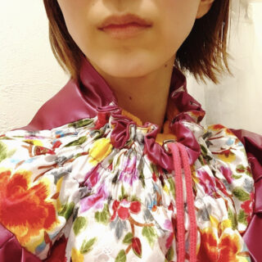

Better than any herb I've tried before!!
This is amazing! Even though my body was cold, I immediately broke into a heavy sweat, and after about 20-30 minutes, my skin started to become smooth. Even after finishing, the sweat wouldn't stop and changing clothes was difficult (laughs). Better than any herb I've tried before!!
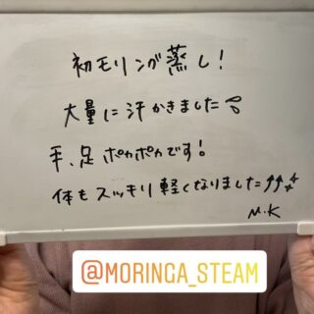

I sweated profusely!
My first Moringa steam! I sweated profusely! My hands and feet are warm! My body feels refreshed and light ♪
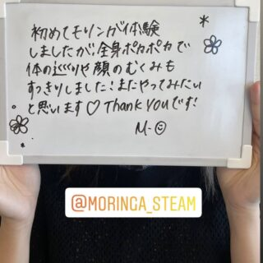

I want to try it again
I experienced Moringa for the first time, and my whole body was warm, and my circulation and facial swelling were refreshed! I want to try it again ♪
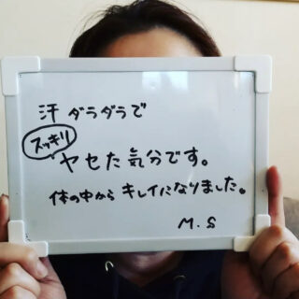

Feeling refreshed and slimmer!
Dripping with sweat, I feel refreshed and slimmer. I've been cleansed from the inside out.
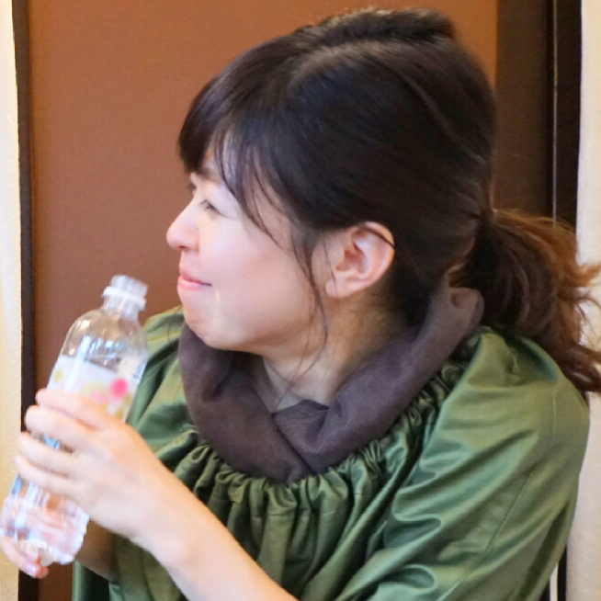

Really refreshed
I sweated profusely. But after finishing, it felt smooth and there was no unpleasant feeling at all. The lingering scent doesn't bother me either. I'm really refreshed!!
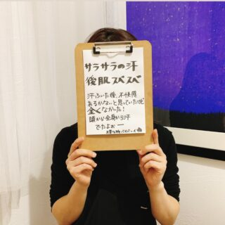

Smooth sweat and silky skin
I thought there might be discomfort after wiping the sweat... but there was none at all! Sweat came out from my head and entire body!


Safe and enjoyable even during pregnancy
I heard it's safe for pregnant women and wanted to try steaming. Currently 8 months pregnant, I have severe swelling, cold feet, and leg cramps, so I'm looking forward to future sessions! Right now, my whole body is warm, like after a bath.
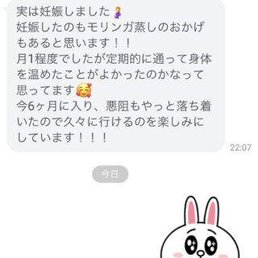

Maybe I got pregnant thanks to Moringa steaming?
Actually, I'm pregnant ♪ I think Moringa steaming also contributed to my pregnancy!! I think regularly visiting and warming my body was good (^-^)


Felt relaxed and refreshed
A few minutes after starting, while relaxing with my eyes closed, large drops of sweat suddenly began flowing non-stop, and even after finishing, the sweat continued for a while. I felt relaxed and refreshed! Clean and refreshing!! Highly recommended


Felt incredibly detoxed
I was soothed by the fresh green scent. The fragrance gradually became gentler. I started sweating earlier than with mugwort steaming. Even after finishing, the sweat wouldn't stop, and I feel incredibly detoxed.


Sweated heavily today
I sweated more than usual. Sometimes my face doesn't sweat, but today I sweated heavily.

Introduction to Certified Salons
Our association's Moringa steaming can be experienced at certified esthetic salons, relaxation salons, chiropractic clinics, and acupuncture clinics nationwide. Please find a store near you.
(Some salons are still being prepared for listing. If there are no nearby stores, please contact us.)
Certified Salon Gallery:
- aesthetic salon Laguna
- Lymph & Detox Salon Lu・cuore
- Esthetic Salon Celestia
- Total Healthcare salon Nilufa
- Yomogi & Moringa Steam Warming Salon Ananta
- Organic & Detox salon Beloved
- EMIE
Furthermore, our association's direct "JMSA Moringa Steam®" can be experienced at salons with Moringa Steam Therapists®.
If you're aiming for constitutional improvement, please contact salons with Moringa Steam Therapists®.
Introduction to Nationwide Certified Salons

For Those Considering Introducing Moringa Steaming
Fortunately, in recent years, awareness of Moringa steaming has increased in the industry, and it has become easier to obtain Moringa as a seat bath agent than before.
However, learning at our association, which started Moringa steaming for the first time in Japan, and introducing Moringa steaming ensures overwhelming specialized knowledge and continuous after-sales support. Above all, we provide food-grade Moringa leaves that have obtained organic certifications both domestically and internationally, so we guarantee that you can confidently offer it to your customers.
We have prepared four courses optimal for your purpose, from courses that can be easily introduced to business opening schools.
About Introduction & Business Opening School

Contact Form
[reCAPTCHA verification required]
Protected by reCAPTCHA
Privacy Policy - Terms of Service

© Japan Moringa Steaming Association (JMSA) Website: www.moringa-steam.com

